EX:No.9 221501060

12/04/25

**Develop neural network-based time series forecasting model**

**Aim:**

ToDevelop neural network-based time series forecasting model

**Algorithm:**

1. **Load the Data**:
   * Read the CSV file containing the weather data.
   * Parse the date column as a datetime index.
2. **Clean the Data**:
   * Handle missing values by performing forward and backward filling.
   * Drop any remaining NaN values.
3. **Normalize the Data**:
   * Apply **Min-Max Scaling** to normalize each column's values between 0 and 1.
4. **Add Time-Based Features**:
   * Extract additional features from the datetime index: day, month and year
5. **Visualize the Data**:
   * Plot the time series for a specific column (e.g., temperature T) over time.
6. **Execute the Program**:
   * Sequentially call the functions to load, clean, normalize, add features, and visualize the data.

Code:

import numpy as np

import pandas as pd

import matplotlib.pyplot as plt

from sklearn.preprocessing import MinMaxScaler

from sklearn.metrics import mean_squared_error

from tensorflow.keras.models import Sequential

from tensorflow.keras.layers import Dense

np.random.seed(42)

date_range = pd.date_range(start='2018-01-01', periods=100, freq='M')

energy_consumption = np.random.normal(loc=300, scale=20, size=100).cumsum()

df = pd.DataFrame({'Date': date_range, 'Energy': energy_consumption})

df.set_index('Date', inplace=True)

scaler = MinMaxScaler()

scaled_energy = scaler.fit_transform(df[['Energy']])

def create_dataset(data, n_steps=3):

X, y = [], []

for i in range(len(data) - n_steps):

X.append(data[i:i + n_steps, 0])

y.append(data[i + n_steps, 0])

return np.array(X), np.array(y)

n_steps = 5

X, y = create_dataset(scaled_energy, n_steps=n_steps)

train_size = int(len(X) * 0.8)

X_train, X_test = X[:train_size], X[train_size:]

y_train, y_test = y[:train_size], y[train_size:]

model = Sequential()

model.add(Dense(64, activation='relu', input_shape=(n_steps,)))

model.add(Dense(32, activation='relu'))

model.add(Dense(1))

model.compile(optimizer='adam', loss='mse')

model.fit(X_train, y_train, epochs=100, verbose=0)

y_pred = model.predict(X_test)

y_pred_rescaled = scaler.inverse_transform(y_pred.reshape(-1, 1))

y_test_rescaled = scaler.inverse_transform(y_test.reshape(-1, 1))

plt.figure(figsize=(10,5))

plt.plot(df.index[-len(y_test):], y_test_rescaled, label='Actual')

plt.plot(df.index[-len(y_test):], y_pred_rescaled, label='Predicted')

plt.legend()

plt.title('Neural Network Forecast on Energy Consumption')

plt.xlabel('Date')

plt.ylabel('Consumption (kWh)')

plt.show()

mse = mean_squared_error(y_test_rescaled, y_pred_rescaled)

print(f'Mean Squared Error: {mse:.2f}')

**Output:**

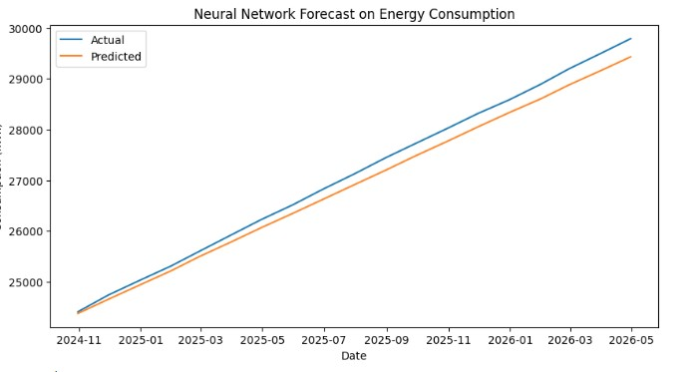

**Result:**

Thus, the program using the time series data implementation has been done successfully.